Cat’s genetics – X inactivation
Female mammals, including human females, inherit two X chromosomes – twice the number inherited by males – so you may wonder whether females make twice as much as males of the proteins encoded by X-linked genes. In fact, almost all of one X chromosome in each cell in female mammals becomes inactivated during early embryonic development. As a result, the cells of females and males have the same effective dose (one copy) of most X-linked genes. The inactive X in each cell of a female condenses into a compact object called a Barr body (discovered by Canadian anatomist Murray Barr), which lies along the inside of the nuclear envelope. Most of the genes of the X chromosome that forms the Barr body are not expressed. In the ovaries, however, Barr-body chromosomes are reactivated in the cells that give rise to eggs, such that following meiosis, every female gamete (egg) has an active X.
British geneticist Mary Lyon demonstrated that the selection of which X chromosome will form the Barr body occurs randomly and independently in each embryonic cell present at the time of X inactivation. As a consequence, females consist of a mosaic of two types of cells: those with the active X derived from the father and those with the active X derived from the mother. After an X chromosome is inactivated in a particular cell, all mitotic descendants of that cell have the same inactive X. Thus, if a female is heterozygous for a sex-linked trait, about half her cells will express one allele, while the others will express the alternate allele. The figure shows how this mosaicism results in the mottled coloration of a tortoiseshell cat. In humans, mosaicism can be observed in a recessive X-linked mutation that prevents the development of sweat glands. A woman who is heterozygous for this trait has patches of normal skin and patches of skin lacking sweat glands. Inactivation of an X chromosome involves modification of the DNA and proteins bound to it, called histones, including attachment of methyl groups (-CH3) to DNA nucleotides. A particular region of each X chromosome contains several genes involved in the inactivation process. The two regions, one on each X chromosome, associate briefly with each other in each cell at an early stage of embryonic development. Then one of the genes, called XIST (for X-inactive specific transcript) becomes active only on the chromosome that will become the Barr body. Multiple copies of the RNA product of this gene apparently attach to the X chromosome on which they are made, eventually almost covering it. Interaction of this RNA with the chromosome initiates X inactivation, and the RNA products of other nearby genes help to regulate the process.
Inactivation and the tortoiseshell cat. The tortoiseshell gene is on the X chromosome, and the tortoiseshell phenotype requires the presence of two different alleles, one for orange fur and one for black fur. Normally, only females can have both alleles, because only they have two X chromosomes. If a female cat is heterozygous for the tortoiseshell gene, she is tortoiseshell. Orange patches are formed by populations of cells in which the X chromosome with the orange allele is active; black patches have cells in which the X chromosome with the black allele is active. ("Calico" cats also have white areas, which are determined by another gene.) | 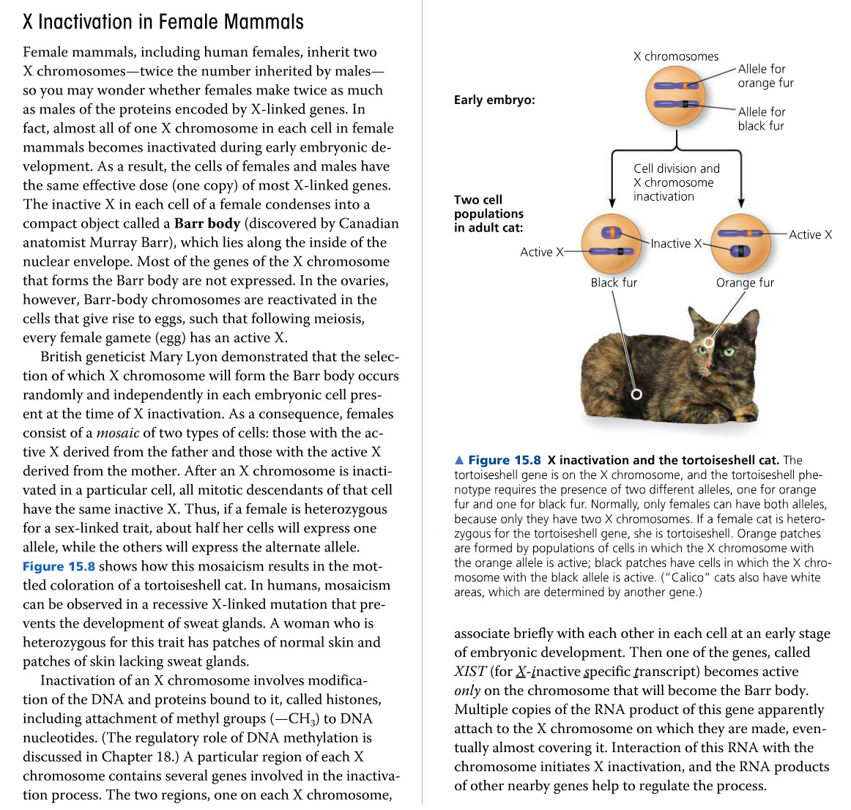

Used Tools and References
- Simon, E. J., Reece, J. B., Dickey, J. L. (2013). Essential Biology with Physiology. (4th edition). Pearson Education.

